2024 AMA National Hare and Hound Championship Series
Supplemental Rules

The 2024 AMA Racing rulebook and these Supplemental rules will govern these events.

CHAMPIONSHIP CLASSES:

The following are the classes in which National Hare and Hound Championship points will be earned. NOTE: The single letter shown below, within the parenthesis ( ), are the class indicators.

- Pro AA (3)  - Pro 250 - 96cc-250cc (X) (3)  - Pro Women (L)(5)  - Pro Vet (35 yrs. & up) (V) (3)  - 98cc-200cc (A) A  - 98cc-200cc (A) B  - 98cc-200cc (A) C  - 201cc-250cc (X) A  - 201cc-250cc (X) B  - 201cc-250cc (X) C  - 251cc-open (none used) A  - 251cc-open (none used) B  - 251cc-open (none used) C  - Veteran (30 yrs. & up) (V) A  - Veteran (30 yrs. & up) (V) B  - Veteran (30 yrs. & up) (V) C  - Senior (40 yrs. & up) (S) A  - Senior (40 yrs. & up) (S) B  - Senior (40 yrs. & up) (S) C | - Super Senior (50 yrs. & up) (M) A  - Super Senior (50 yrs. & up) (M) B  - Super Senior (50 yrs. & up) (M) C  - Masters 60+ (R)  - Pioneer 70+ (P)  - Women 98cc-Open (L) A  - Women 98cc-Open (L) B  - Women 98cc-Open (L) C  - Women Vet 98cc- Open (35+ yrs.) (Y)  - Sportsmen 98cc-Open (7)  - Trophy 98cc-Open (T) (8)  - Adventure Open 750cc-Open (E) (9)  - Hooligan Open 750cc-Open (H) (10)

- It is the rider's responsibility to enter the proper class. Failure to do so will result in the loss of all points earned. Example: if you ride the "A" class locally must enter the "A" class in the Championship series.

- Locally and Nationally designated AA riders must enter Pro AA, Pro 250, Pro Women and Pro Vet classes.

- Pro AA: Riders wishing to enter the Pro AA class can request placement. Once a rider enters and earns points towards the Pro AA they must enter Pro AA for the rest of the season. Points are earned by finishing within the top 20 overall against all Pro and A classes on the course simultaneously. No class points will be earned.

- PRO 250 Class: Riders wishing to enter the Pro 250 class can request placement. Once a rider enters and earns points towards the Pro 250 they must enter Pro 250 for the rest of the season. Points are earned against other Pro 250 riders. Riders will still receive overall points.

- PRO WOMEN: Riders wishing to enter the Pro Women class can request placement. Once a rider enters and earns points towards Pro Women they must enter Pro Women for the rest of the season.
- PRO VET: Riders wishing to enter the Pro Vet class can request placement. Once a rider enters and earns points towards the Pro Vet, they must enter Pro Vet for the rest of the season. Points are only received based on overall Vet finish (identical to Pro AA)

- SPORTSMEN: First time racers who have not yet raced A/B/C classes. Riders receive No AMA Points or Trophies. Class will only need to complete 1 lap to be considered a finisher. Class will start with last starting Motorcycle Row. Riders can enter Sportsmen as often as they wish.

- TROPHY: All skill level riders eligible. Riders receive event trophy and points but are not eligible for AMA National Championship. Class will only need to complete 1 lap to be considered a finisher. Class will start with last starting Motorcycle Row. Riders can enter Trophy as often as they wish.

- ADVENTURE: 750cc and higher multi-cylinder bikes only. Must use stock production frames only. No neck modifications allowed to stock frames. Minimum 16” each wheel size.

- HOOLIGAN: 750cc and higher multi-cylinder bikes only. Must use stock production frames only. No neck modifications allowed to stock frames. Minimum 16” each wheel size. Air Cooled. Liquid cooled allowed for dual rear shock machines.

NUMBERS AND BACKGROUNDS:

- All riders must run a requested and approved series number, unless the rider is a member of the co-sanctioned organization. All other riders must run an NHHA-issued temporary number, and all other numbers must be covered. Failure to do so may result in 5-minute penalty.

- All national numbers must be indicated by "N" at the beginning of their approved number, except for Pro AA, Pro 250, Pro Women and Pro Vet.
- Riders are required to run their correct background and number color for the class they enter. Failure to do so may result in disqualification and loss of points earned.
- Series riders will receive priority of approved numbers for the event. Failure to run correct numbers may result in disqualification.

- Number requests will be granted in order of date received.

- *See Class Number guide on the following page for overview.

Class Number Guide:

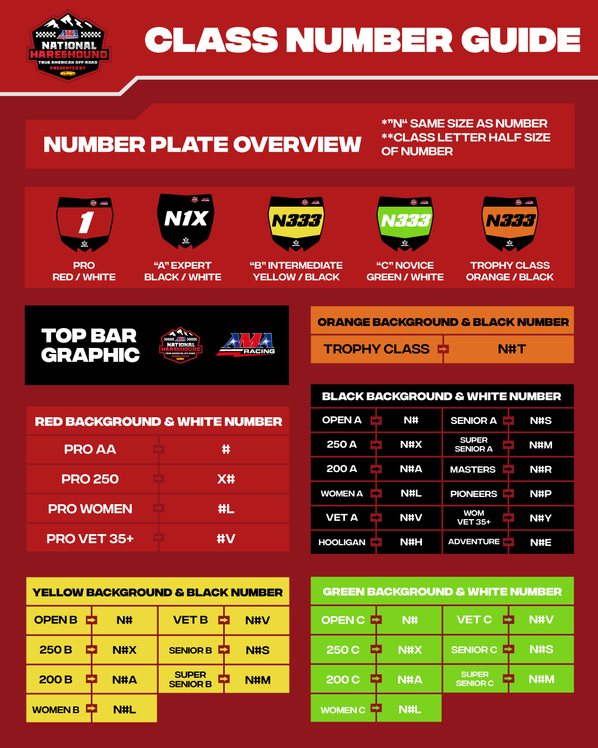

START PROCEDURES:

- The start area, from start line to the end of the start stretch as marked, will be considered the “Bomb Run” and may be scouted via walking or riding and at the NHHA’s discretion. Riders may scout the bomb run on a pedal-assist electric bicycle. The use of throttle powered bicycles or motorcycles is not permitted.

- “End of Bomb” flags will indicate the end of the start area, and beginning of the course. No rider shall be permitted to scout past the “End of Bomb” flags prior to the start of the event. All riders must go through the End of Bomb flags, unless otherwise stated in the rider’s meeting. Riders who fail to do so may be subject to disqualification or penalty at the Official Race Referee’s discretion.
- Any rider obviously off-course will be subject to disqualification. A rider will be considered obviously off-course if he/she is beyond 50 feet on either side of the course markings and has gained an obvious advantage (i.e. riding on a road or jumping out of a sand wash.)
- If the BLM or rules of the property dictate a “start-by-class” format this will be communicated via official NHHA communication prior to the event, or onsite in the event of an emergency.

- The start shall be a mass start, with a banner drop, with no less than 500 meters in length of open terrain.
- Rider attendance at the rider's meeting is mandatory prior to the start of the race. Riders not in attendance may be subject to a 5-minute penalty.

- When different classes run a different or partial course, the instructions will be included in the rider’s meeting.

- All starts will be dead engine with the rider astride their motorcycle.

- The banner will be raised at least one (1) minute, and then dropped forward, signaling the start of the race. No one may display additional banners that may be confusing. In case of a false start, the banner shall be rolled up while in the vertical position and taken down slowly. Once the course is clear, the regular starting procedure will resume.

- If a larger than expected entry requires that the start line be extended on the day of the event, only the end with the least advantage will be moved.

- To hold a starting line spot, either an entered bike or rider must be present. Crates, practice bikes or pit crews will not reserve a starting line spot. Bikes may not be placed on the starting line while there is an active race in progress.

- Riders must start between the feather flags that coordinate with their skill level. Novice and Beginner rows may be combined at Referee discretion:
  - Red- Pro/AA
  - Black- Expert (A)
  - Yellow- Intermediate (B)
  - Green- Novice (C)
  - White- Beginner, Non-National Support Classes

- If “Start by Class” format is utilized Pro AA, Pro 250 and top 20 in points must start on front row, then Pro Women and Pro Vet in the next row, A classes in the next rows, followed by B classes, then C classes and all remaining classes.
- Rider’s may not move up from their designated row, unless otherwise stated in the rider’s meeting.

RACE PROCEDURES:

- A National Hare & Hound course shall be approximately 70-100 miles, and gas pits shall be no more than 40 miles apart.

- All riders are required to complete tech inspection and sound check, as required, before the race. Tech and sound inspection shall be located near Registration, and additional tech inspection may be performed on the start line at club’s discretion. Failure to complete tech inspection shall result in disqualification.

- All Riders must stop at checks for positive identification. A check shall be considered legal if at least 75% of the riders clear the following check. All riders must remain on course and approach checks from the proper direction. In the event the race may not be adequately scored at the end of the final loop, the most recent legal check may be used to score the event.

- Unless otherwise instructed at the riders meeting, riders must not ride more than 50 feet on either side of the course markings. Failure to follow this rule may results in penalty or disqualification.

- Finishing position shall be determined by order of finish at the checkered flag with all legal consecutive checks. Riders must complete listed distance of their class to be considered a finish. The checkered flags at the scoring tower signify the end of the loop. Any rider racing after passing the checkered flags is subject to disqualification.

- Riders shall not pass in the scoring chute. Riders aggressively speeding or passing will be penalized at the Official Race Referee’s discretion. Riders who damage the finish line or scoring chute due to reckless racing are subject to a 5-minute penalty.

- Pit areas shall be one sided, unless otherwise stated.

- Pit speeds shall be limited to 15 miles per hour and shall be patrolled by officials. Riders caught speeding in the pits are subject to a 5-minute penalty.

- Riders must enter and exit pits at designated Red entrance flags, and Green exit flags. Failure to do so will result in a minimum 60-second penalty.

- If you miss the pits, you must kill your bike and walk it backwards to the entrance. If not walkable due to terrain, bike may be ridden at a safe pace. Riders who enter pits backwards will receive a 1 position penalty.

- Riders may not pass in the pits unless rider being approached is clearly pulling into their pit space. Riders caught passing the in the pits will receive a 1-minute penalty.

- Racers and their team may not park in designated Team Pit Parking spaces unless it is their reserved space. Parking in a reserved space may result in disqualification.

- Super Senior C, Masters, Pioneers, Trophy, Sportsmen, Adventure, Hooligan, and Women Vet 35+ classes’ race will be complete after the first loop unless instructed otherwise.

- Loop 2 and higher (i.e Loop 3) will close one (1) hour after the first rider in the lowest skill level heads out onto the subsequent loop.

PROGRAM:

- All events will be scored by NHHA Scoring Officials.

- Events may run regardless of inclement conditions. In the event of unfavorable or unsafe conditions, the NHHA and official race referee may alter the order or duration of the event schedule. Including but not limited to adjusting the length, delaying the start or throwing the checkered flag.

- At each event, all Championship classes must be run as listed in the Supplemental rules including class displacement. At the NHHA’s option, additional support classes may be run. If youth support classes, and/or beginners support classes are offered, they must be run separate from the Championship program.

- Any "B" rider finishing in the top 20 Overall results must advance to the "A" class effective January 1st of the following year.

- Riders must finish under their own physical power. Towing, outside assistance or getting to the finish line by any other means will result in disqualification.

- Tracking devices may be used for safety and scoring purposes. Trackers may or may not be used in the event of a protest or appeal.

- Riders who are provided an official NHHA-issued tracking device must run the device from start to finish. Riders are 100% responsible for securing, activating, and returning the tracker for each event. Riders or teams caught tampering, manipulating, or destroying the tracking device will be subject to disqualification.

- Course will be marked according to “The Kurt Caselli Foundation Course Marking System”.

PROTEST PROCEDURE:

- All protests must be handwritten, signed, and submitted only by the person directly concerned.
- Each protest must refer to a single subject and presented to the Official Race Referee within 30-minutes of results posting onsite.
- A Protest deposit of $50 must accompany the protest.

- Photo or video evidence of course cutting will result in penalty at the race referee’s discretion.

- Once results are posted online following the completion of event; classification appeals will be accepted up to 48 hours after. All results and points will be final following the 48-hour appeal period.

NATIONAL CHAMPIONS:

- Riders finishing in the top 10 of the preceding year will be designated as Pro Class riders for the following year and must enter Pro AA or Pro 250 Classes. Pro AA riders are only eligible for Overall and "Pro" awards.

  - Riders who have won the Pro 250 championship twice within the previous 5 years must enter Pro AA.

- The top 20 overall riders will be scored in addition to their displacement class standings. At each meet, the top twenty (20) overall finishers receive points toward the AMA National Hare & Hound Overall Championship. An overall winner shall be crowned at the conclusion of the series based on National points earned.

- The top 20 Overall riders may display their earned number.

- A class champions may run their earned number one plate, and all other champions in the B and C classes may run their earned overall number based on total riders in class segment, if they choose.

- Riders may request to run a number that has not been earned. Requests granted by date received.

National points will be based on the following points schedule:

Finish /Points  1 - 30  2 - 25  3 - 21  4 - 18  5 - 16 | Finish /Points  6 - 15  7 - 14  8 - 13  9 - 12  10 - 11 | Finish /Points  11 - 10  12 - 9  13 - 8  14 - 7  15 - 6 | Finish /Points  16 - 5  17 - 4  18 - 3  19 - 2  20 – 1

Example: At a series meet, a rider may finish first in the 250cc class and third overall. He would receive 30 points for his 250cc class win and 21 points toward the National Championship. Class points and overall points shall be kept separately by the AMA.

- A rider must compete in 75% of the total number of events to be eligible for series awards. If the event total is odd, the count will round up. The Pro AA, Pro 250, Pro Women and Pro Vet championships will count the riders' scores from all rounds. Each class championship will drop its two lowest scores if there are nine or more events and one lowest if there are eight or fewer events. The original number of throwaways will be counted if rounds are canceled during the series. Riders may not use a canceled round as a throwaway.

